

SETHU INSTITUTE OF TECHNOLOGY
(An Autonomous Institution | Accredited with ‘A++’ Grade by NAAC)
PULLOOR, KARIAPATTI – 626 115

DEPARTMENT OF COMPUTER SCIENCE AND
BUSINESS SYSTEMS

LAB RECORD

Regulation - 2021

R21UCB863-VISUALIZATION USING TABLEAU LABORATORY

Name : Year :

Reg.no : Semester:

Degree : Branch:

Subject Code/Name :

BONAFIDE CERTIFICATE

Name of the student:

Register no:

This is to certify that this is a Bonafide record of the work done by the above student with in___________ semester B.Tech Degree in_____________________
____________________________ in the_________________________________ laboratory during the academic year 2025-2026.

Faculty in Charge Head of the Department
Date:

Submitted for the practical examination held on ____________________

Internal Examiner External Examiner

Index

S.No | Date  of Exp. | Name of the experiment | Mark | Signature

Faculty in Charge

PROGRAMME | B.Tech. Computer Science and Business Systems

Department Vision (CSBS) | To promote excellence in producing industry perspective professionals to serve the society through technical knowledge and research
Department Mission (CSBS) | - To provide Technical sound knowledge professionals in computer science and business system to meet industry needs  - To provide comprehensive based learning platform  - To impart varied skill sets that meets industry standards for better employability and entrepreneurship  - To collaborate with industries for effective linkage  - To carryout research & innovation activities for the development of the society  - To serve the society through technology, managerial skills and human values
Core Values | Quality| Dedication | Creativity | Team work

 | PROGRAMME EDUCATIONAL OBJECTIVES
PEO – I | To Exhibit technical skills to Solve, analyze, evaluate, design and develop engineering solutions to cater the needs of the industries. [Technical Skills]
PEO – II | To ignite the passion for Entrepreneurship through Managerial skills and apply modern tools of management in complex decision making process. [Managerial  Skills]
PEO – III | To hone professional expertise by engaging in research and inculcate a spirit of Ethics and Social Commitment through sustained learning. [Sustainable Learning]

 | PROGRAMME SPECIFIC OUTCOMES
PSO1 | Apply principles of Computer Science and problem solving skills through programming techniques to solve complex real time problems.[Programming  Techniques]
PSO2 | Exhibit the knowledge of management principles and demonstrate critical- thinking and problem solving skills in Business Management.[ManagementSkills]

 | PROGRAMME OUTCOMES
PO1 | Apply knowledge of mathematics, science, engineering fundamentals, and an engineering specialization to solve complex engineering problems. [Engineering Knowledge]
PO2 | Identify, formulate, review literature, and analyze complex engineering problems to reach substantiated conclusions using first principles of mathematics, natural sciences, and engineering sciences. [Problem Analysis]
PO3 | Design solutions for complex engineering problems and design systems, components, or processes that meet specified needs considering societal, environmental, safety, and cultural factors. [Design/Development of Solutions]
PO4 | Use research-based knowledge and methods including design of experiments, analysis, and interpretation of data to provide valid conclusions.[ Conduct Investigations of Complex Problems]
PO5 | Create, select, and apply appropriate techniques, resources, and modern engineering and IT tools for complex engineering activities with an understanding of limitations. [Modern Tool Usage]
PO6 | Apply reasoning informed by contextual knowledge to assess societal, health, safety, legal, and cultural issues relevant to professional engineering practice. [Engineering and Society]
PO7 | Understand the impact of engineering solutions in societal and environmental contexts and demonstrate knowledge of sustainable development. [Environment and Sustainability]
PO8 | Apply ethical principles, professional norms, and responsibilities in engineering practice. [Ethics and Professionalism]
PO9 | Function effectively as an individual, and as a member or leader in diverse teams and in multidisciplinary environments.[ Individual and Team Work]
P10 | Communicate effectively on complex engineering activities with the engineering community and society through reports, presentations, and documentation. [Communication]
P11 | Recognize the need for and have the ability to engage in independent and lifelong learning in the broadest context of technological change. [Lifelong Learning]

SYLLABUS

R21UCB863 | VISUALIZATION USING TABLEAU LABORATORY | L | T | P | C
R21UCB863 | VISUALIZATION USING TABLEAU LABORATORY | 0 | 0 | 2 | 1
COURSE OBJECTIVES :
The student should be made to:
- Understand the basics of data visualization and analytics.
- Learn to use Tableau to create various charts, plots, and dashboards.
- Analyze and interpret data using different visualization techniques.
- Apply filters, sorting, and other data manipulation techniques in Tableau.
- Develop the ability to present insights using visual data representations.

LIST OF EXPERIMENTS
- To understand how to create a Tree Map and analyze hierarchical data
- To visualize data hierarchically using a Tree Map
- To represent data distribution and proportions using Histogram and Pie Chart
- To analyze data spread using Box Plot and schedule/timeline representation using Gantt Chart
- To study trends in data using Trend Line
- To learn how to plan and modify schedules effectively
- To understand data manipulation using filtering and sorting techniques
- To represent relationships and patterns in data using Charts and Scatter Plot

SUGGESTED DOMAINS:

Retail & E-Commerce:  Retail Sales Performance Dashboard  Customer Segmentation & RFM Analysis  E-Commerce Conversion Funnel Analytics  Sales Forecasting Dashboard  Profitability Analysis for Retail Products  Banking & Finance:  Financial Budget vs Actual Dashboard  Bank Loan Default Prediction Dashboard  Credit Card Spending Insights  Investment Portfolio Performance Analytics  Insurance Claim Fraud Analytics  Healthcare & Hospitals:  Hospital Patient Flow Dashboard  Disease Outbreak Trend Analysis  Medical Billing & Revenue Cycle Dashboard  ICU Bed Utilisation Analytics  Doctor Performance & Appointment Dashboard | Marketing & Digital Media:  Digital Marketing Campaign Performance  SEO Keyword Ranking Dashboard  Instagram / Facebook Engagement Analytics  Customer Journey Analytics  Brand Sentiment Analysis Dashboard  Governance, Environment & Public Data:  Crime Rate Statistics Dashboard  Smart City Transportation Analytics  Pollution & Air Quality Monitoring Dashboard  Water Quality Index Dashboard  Election Results Visualization  Education & Student Analytics:  Student Attendance & Performance Dashboard  Online Course Engagement Dashboard  Placement Performance Analysis  Teacher Performance Dashboard  Admission Trend Analysis

Total Periods :30
COURSE OUTCOMES:
At the end of the course, the students will be able to:
- Understand basic concepts of data visualization and its tools. [Understand]
- Apply Tableau to create interactive dashboards and visualizations for real-world data. [Apply]
- Analyze datasets to extract meaningful insights using charts, filters, and trend lines. [Analyze]
- Design visualization models for complex datasets using Tableau techniques. [Design]
- Create interactive visualizations and dashboards for various real-time applications. [Create]
- Work individually or in teams to demonstrate data analysis and visualizations using modern tools. [Modern Tools]

EX.NO 1: Creating a Tree Map using Tableau (with Dataset Creation)- Road Accident Analysis
DATE:
Aim:
To design a specialized road accident dataset and utilize Tableau’s hierarchical visualization capabilities to identify high-risk road categories and geographical hotspots.

Applications:
- Blackspot Identification: Pinpointing specific road types (Highways vs. Residential) with the highest accident frequency.
- Resource Allocation: Assisting emergency services in prioritizing patrol units in highrisk zones.
- Infrastructure Planning: Providing data-driven evidence for installing dividers, lighting, or traffic signals.
- Policy Impact Assessment: Comparing regional safety compliance levels to evaluate the success of traffic laws.
- Emergency Response Mapping: Categorizing areas by severity to optimize ambulance placement.

Procedure:
- Dataset Construction:
  - Open Microsoft Excel and create a worksheet titled Road_Accident_Master. o Define headers: Accident_ID, Road_Type, Region, Weather, Accidents_Count, and Fatality_Rate.
  - Populate with 15–20 rows of varied data (e.g., Rural, East, Foggy, 340, 0.12).
  - Save the file as Road_Analysis_Data.xlsx.
- Data Integration:
  - Launch Tableau Desktop. Under the Connect pane, select Microsoft Excel and locate your saved file.
  - Drag the sheet into the canvas area to ensure data types (String, Number) are correctly identified.
- Building the Hierarchy:
  - Navigate to Sheet 1. o Drag the Road_Type dimension to the Color marks card. o Drag the Accidents_Count measure to the Size marks card.
- Detailing and Labeling:
  - Drag Region to the Labelmarks card to create the nested effect within the road types.
  - Drag Accidents_Count to Label to display the numerical values on each block. o Click on Label $\rightarrow$ Appearance and check "Allow labels to overlap other marks" if some small boxes are hidden.
- Refinement:
  - Select Tree Map from the Show Me panel. oRight-click the Color legend, select Edit Colors, and choose a "Red-Blue Diverging" palette to represent danger levels (Red for high, Blue for low).

Output:

Accident_ID | Accident_Date | Road_Type | Vehicle_Type | Vehicle_Age | Accident_Severit | Vehicles |  | Casualties |  | Clear_Time
ACC001 | 2000-01-15 | Single Carriagew | Car | 5 | Slight |  | 2 |  | 1 | 45
ACC002 | 2000-04-22 | Dual Carriagewa | yMotorcycle | 2 | Fatal |  | 1 |  | 1 | 120
ACC003 | 2000-09-10 | Roundabout | Bus | 10 | Serious |  | 2 |  | 5 | 95
ACC004 | 2001-02-05 | Single Carriagew | Van | 7 | Slight |  | 2 |  | 2 | 40
ACC005 | 2001-07-18 | Dual Carriagewa | yHGV | 4 | Fatal |  | 3 |  | 2 | 210
ACC006 | 2001-11-30 | One-way street | Bicycle | 1 | Slight |  | 1 |  | 1 | 15
ACC007 | 2002-03-12 | Single Carriagew | Car | 12 | Serious |  | 2 |  | 3 | 80
ACC008 | 2002-08-25 | Roundabout | Car | 3 | Slight |  | 2 |  | 1 | 35
ACC009 | 2002-12-01 | Dual Carriagewa | yMotorcycle | 1 | Serious |  | 1 |  | 1 | 110
ACC010 | 2003-05-14 | Single Carriagew | Van | 15 | Slight |  | 2 |  | 2 | 50
ACC011 | 2003-10-20 | Dual Carriagewa | yCar | 6 | Fatal |  | 4 |  | 6 | 300
ACC012 | 2004-01-15 | Roundabout | Bicycle | 2 | Slight |  | 2 |  | 1 | 30
ACC013 | 2004-06-30 | Single Carriagew | Car | 20 | Serious |  | 1 |  | 1 | 85
ACC014 | 2004-11-12 | One-way street | Bus | 8 | Slight |  | 2 |  | 7 | 105
ACC015 | 2005-03-22 | Dual Carriagewa | yHGV | 5 | Fatal |  | 2 |  | 2 | 185
ACC016 | 2005-08-01 | Single Carriagew | Motorcycle | 3 | Slight |  | 2 |  | 1 | 40
ACC017 | 2006-01-15 | Roundabout | Car | 9 | Slight |  | 2 |  | 2 | 55
ACC018 | 2006-06-20 | Dual Carriagewa | yCar | 2 | Serious |  | 3 |  | 4 | 145
ACC019 | 2006-11-25 | Single Carriagew | Van | 11 | Slight |  | 2 |  | 2 | 60
ACC020 | 2007-04-10 | One-way street | Bicycle | 0 | Slight |  | 1 |  | 1 | 20
ACC021 | 2007-09-05 | Dual Carriagewa | yCar | 4 | Fatal |  | 2 |  | 3 | 220
ACC022 | 2008-02-14 | Single Carriagew | Motorcycle | 6 | Serious |  | 1 |  | 1 | 90
ACC023 | 2008-07-22 | Roundabout | Bus | 12 | Slight |  | 2 |  | 4 | 70
ACC024 | 2008-12-30 | Dual Carriagewa | yHGV | 8 | Serious |  | 3 |  | 2 | 160
ACC025 | 2009-05-12 | Single Carriagew | Car | 14 | Slight |  | 2 |  | 1 | 45
ACC026 | 2009-10-18 | One-way street | Car | 7 | Slight |  | 2 |  | 2 | 35
ACC027 | 2010-03-25 | Dual Carriagewa | yMotorcycle | 2 | Fatal |  | 1 |  | 1 | 130
ACC028 | 2010-09-02 | Roundabout | Van | 5 | Slight |  | 2 |  | 2 | 45
ACC029 | 2011-02-10 | Single Carriagew | Car | 3 | Serious |  | 2 |  | 3 | 85
ACC030 | 2011-07-15 | Dual Carriagewa | yCar | 10 | Slight |  | 2 |  | 1 | 50
ACC031 | 2011-12-22 | One-way street | Bicycle | 1 | Slight |  | 1 |  | 1 | 15
ACC032 | 2012-05-05 | Roundabout | Bus | 15 | Serious |  | 2 |  | 10 | 140
ACC033 | 2012-10-12 | Dual Carriagewa | yHGV | 3 | Fatal |  | 4 |  | 4 | 310
ACC034 | 2013-03-18 | Single Carriagew | Car | 6 | Slight |  | 2 |  | 2 | 40
ACC035 | 2013-08-25 | Dual Carriagewa | yMotorcycle | 1 | Serious |  | 1 |  | 1 | 100
ACC036 | 2014-01-10 | Roundabout | Van | 9 | Slight |  | 2 |  | 2 | 55
ACC037 | 2014-06-15 | Single Carriagew | Car | 18 | Fatal |  | 2 |  | 2 | 240
ACC038 | 2014-11-20 | Dual Carriagewa | yCar | 5 | Serious |  | 3 |  | 3 | 130
ACC039 | 2015-04-05 | One-way street | Bicycle | 2 | Slight |  | 1 |  | 1 | 20
ACC040 | 2015-09-12 | Roundabout | Bus | 6 | Slight |  | 2 |  | 5 | 80
ACC041 | 2016-02-18 | Single Carriagew | Car | 11 | Slight |  | 2 |  | 1 | 45
ACC042 | 2016-07-25 | Dual Carriagewa | yHGV | 7 | Fatal |  | 2 |  | 1 | 190
ACC043 | 2016-12-30 | One-way street | Van | 4 | Slight |  | 2 |  | 2 | 50
ACC044 | 2017-06-05 | Single Carriagew | Motorcycle | 3 | Serious |  | 1 |  | 1 | 115
ACC045 | 2017-11-12 | Roundabout | Car | 2 | Slight |  | 2 |  | 2 | 40
ACC046 | 2018-04-20 | Dual Carriagewa | yCar | 13 | Serious |  | 3 |  | 5 | 150
ACC047 | 2018-09-25 | Single Carriagew | Bus | 9 | Slight |  | 2 |  | 8 | 110
ACC048 | 2019-02-10 | One-way street | Bicycle | 1 | Slight |  | 1 |  | 1 | 25
ACC049 | 2019-07-15 | Dual Carriagewa | yHGV | 5 | Fatal |  | 3 |  | 3 | 250
ACC050 | 2019-12-20 | Roundabout | Motorcycle | 4 | Serious |  | 1 |  | 1 | 105
ACC051 | 2020-01-05 | Single Carriagew | Car | 16 | Slight |  | 2 |  | 1 | 55
ACC052 | 2020-02-10 | Dual Carriagewa | yCar | 8 | Fatal |  | 2 |  | 2 | 210
ACC053 | 2020-03-15 | One-way street | Van | 6 | Serious |  | 2 |  | 3 | 90
ACC054 | 2020-04-20 | Roundabout | Car | 1 | Slight |  | 2 |  | 2 | 35
ACC055 | 2020-05-25 | Single Carriagew | Bicycle | 3 | Slight |  | 1 |  | 1 | 30
ACC056 | 2020-06-30 | Dual Carriagewa | yBus | 11 | Serious |  | 2 |  | 12 | 160

ACC057 | 2020-07-05 | One-way street | HGV | 9 | Fatal | 2 | 1 | 200
ACC058 | 2020-08-10 | Roundabout | Motorcycle | 2 | Slight | 2 | 1 | 45
ACC059 | 2020-09-15 | Single Carriagew | Car | 5 | Serious | 2 | 2 | 75
ACC060 | 2020-10-20 | Dual Carriagewa | yCar | 10 | Slight | 2 | 1 | 55
ACC061 | 2020-11-25 | One-way street | Van | 12 | Slight | 2 | 2 | 40
ACC062 | 2020-12-30 | Roundabout | Car | 4 | Fatal | 3 | 4 | 230
ACC063 | 2021-01-05 | Single Carriagew | Bicycle | 0 | Slight | 1 | 1 | 20
ACC064 | 2021-02-10 | Dual Carriagewa | yMotorcycle | 1 | Serious | 1 | 1 | 110
ACC065 | 2021-03-15 | One-way street | Bus | 7 | Slight | 2 | 6 | 90
ACC066 | 2021-04-20 | Roundabout | HGV | 6 | Fatal | 2 | 2 | 180
ACC067 | 2021-05-25 | Single Carriagew | Car | 14 | Slight | 2 | 1 | 50
ACC068 | 2021-06-30 | Dual Carriagewa | yVan | 3 | Serious | 2 | 2 | 100
ACC069 | 2021-07-05 | One-way street | Motorcycle | 5 | Slight | 2 | 1 | 35
ACC070 | 2021-08-10 | Roundabout | Car | 2 | Serious | 2 | 3 | 85
ACC071 | 2021-09-15 | Single Carriagew | Car | 11 | Fatal | 3 | 5 | 280
ACC072 | 2021-10-20 | Dual Carriagewa | yBicycle | 1 | Slight | 1 | 1 | 30
ACC073 | 2021-11-25 | One-way street | Bus | 15 | Serious | 2 | 9 | 130
ACC074 | 2021-12-30 | Roundabout | HGV | 8 | Fatal | 4 | 3 | 320
ACC075 | 2022-01-05 | Single Carriagew | Van | 5 | Slight | 2 | 2 | 45
ACC076 | 2022-02-10 | Dual Carriagewa | yCar | 6 | Serious | 2 | 4 | 110
ACC077 | 2022-03-15 | One-way street | Motorcycle | 2 | Slight | 1 | 1 | 25
ACC078 | 2022-04-20 | Roundabout | Car | 12 | Slight | 2 | 1 | 50
ACC079 | 2022-05-25 | Single Carriagew | Car | 3 | Serious | 3 | 6 | 155
ACC080 | 2022-06-30 | Dual Carriagewa | yBus | 5 | Fatal | 2 | 3 | 240
ACC081 | 2022-07-05 | One-way street | Bicycle | 2 | Slight | 1 | 1 | 15
ACC082 | 2022-08-10 | Roundabout | Van | 10 | Serious | 2 | 2 | 95
ACC083 | 2022-09-15 | Single Carriagew | HGV | 4 | Fatal | 2 | 2 | 190
ACC084 | 2022-10-20 | Dual Carriagewa | yMotorcycle | 3 | Slight | 2 | 1 | 40
ACC085 | 2022-11-25 | One-way street | Car | 7 | Serious | 2 | 3 | 80
ACC086 | 2022-12-30 | Roundabout | Car | 1 | Slight | 2 | 1 | 30
ACC087 | 2023-01-05 | Single Carriagew | Bus | 13 | Serious | 2 | 5 | 115
ACC088 | 2023-02-10 | Dual Carriagewa | yBicycle | 0 | Slight | 1 | 1 | 20
ACC089 | 2023-03-15 | One-way street | Van | 9 | Fatal | 2 | 1 | 210
ACC090 | 2023-04-20 | Roundabout | Motorcycle | 6 | Serious | 1 | 1 | 100
ACC091 | 2023-05-25 | Single Carriagew | HGV | 11 | Slight | 3 | 2 | 70
ACC092 | 2023-06-30 | Dual Carriagewa | yCar | 5 | Fatal | 2 | 4 | 250
ACC093 | 2023-07-05 | One-way street | Car | 4 | Slight | 2 | 2 | 45
ACC094 | 2023-08-10 | Roundabout | Bus | 16 | Serious | 2 | 7 | 125
ACC095 | 2023-09-15 | Single Carriagew | Van | 2 | Slight | 2 | 1 | 35
ACC096 | 2023-10-20 | Dual Carriagewa | yBicycle | 3 | Slight | 1 | 1 | 25
ACC097 | 2023-11-25 | One-way street | HGV | 8 | Fatal | 3 | 2 | 230
ACC098 | 2023-12-30 | Roundabout | Motorcycle | 1 | Serious | 1 | 1 | 105
ACC099 | 2024-01-05 | Single Carriagew | Car | 10 | Slight | 2 | 2 | 50
ACC100 | 2024-02-10 | Dual Carriagewa | yCar | 3 | Serious | 2 | 3 | 90
ACC101 | 2024-03-15 | Single Carriagew | Van | 7 | Slight | 2 | 1 | 40
ACC102 | 2024-04-20 | Dual Carriagewa | yHGV | 6 | Fatal | 2 | 1 | 185
ACC103 | 2024-05-25 | Roundabout | Motorcycle | 2 | Slight | 2 | 1 | 30
ACC104 | 2024-06-30 | Single Carriagew | Car | 4 | Serious | 2 | 3 | 75
ACC105 | 2024-07-05 | One-way street | Bus | 12 | Serious | 2 | 5 | 110
ACC106 | 2024-08-10 | Dual Carriagewa | yCar | 1 | Slight | 2 | 2 | 40
ACC107 | 2024-09-15 | Roundabout | Bicycle | 5 | Slight | 1 | 1 | 15
ACC108 | 2024-10-20 | Single Carriagew | HGV | 10 | Fatal | 3 | 4 | 260
ACC109 | 2024-11-25 | Dual Carriagewa | yCar | 8 | Slight | 2 | 1 | 45
ACC110 | 2024-12-30 | One-way street | Van | 3 | Serious | 2 | 2 | 90
ACC111 | 2025-01-05 | Roundabout | Motorcycle | 2 | Fatal | 1 | 1 | 120
ACC112 | 2025-01-10 | Single Carriagew | Car | 6 | Slight | 2 | 2 | 40
ACC113 | 2025-01-15 | Dual Carriagewa | yBus | 9 | Serious | 2 | 6 | 150

ACC114 | 2025-01-20 | One-way street | Car | 11 | Slight | 2 | 1 | 50
ACC115 | 2025-01-25 | Roundabout | HGV | 4 | Fatal | 2 | 2 | 200
ACC116 | 2025-02-01 | Single Carriagew | Bicycle | 1 | Slight | 1 | 1 | 20
ACC117 | 2025-02-05 | Dual Carriagewa | yMotorcycle | 3 | Serious | 1 | 1 | 115
ACC118 | 2025-02-10 | One-way street | Van | 7 | Slight | 2 | 2 | 55
ACC119 | 2025-02-15 | Roundabout | Car | 2 | Serious | 2 | 3 | 80
ACC120 | 2025-02-20 | Single Carriagew | HGV | 13 | Fatal | 3 | 2 | 240
ACC121 | 2025-02-25 | Dual Carriagewa | yCar | 5 | Slight | 2 | 1 | 45
ACC122 | 2025-03-01 | One-way street | Bus | 10 | Slight | 2 | 4 | 70
ACC123 | 2025-03-05 | Roundabout | Motorcycle | 1 | Serious | 1 | 1 | 95
ACC124 | 2025-03-10 | Single Carriagew | Van | 6 | Slight | 2 | 2 | 50
ACC125 | 2025-03-15 | Dual Carriagewa | yCar | 4 | Fatal | 3 | 5 | 280
ACC126 | 2025-03-20 | One-way street | Bicycle | 2 | Slight | 1 | 1 | 15
ACC127 | 2025-03-25 | Roundabout | HGV | 9 | Serious | 2 | 2 | 130
ACC128 | 2025-04-01 | Single Carriagew | Car | 15 | Serious | 2 | 4 | 100
ACC129 | 2025-04-05 | Dual Carriagewa | yMotorcycle | 2 | Fatal | 1 | 1 | 140
ACC130 | 2025-04-10 | One-way street | Van | 5 | Slight | 2 | 2 | 40
ACC131 | 2025-04-15 | Roundabout | Bus | 11 | Serious | 2 | 8 | 160
ACC132 | 2025-04-20 | Single Carriagew | Car | 7 | Slight | 2 | 1 | 35
ACC133 | 2025-04-25 | Dual Carriagewa | yHGV | 3 | Fatal | 2 | 2 | 210
ACC134 | 2025-05-01 | One-way street | Bicycle | 1 | Slight | 1 | 1 | 20
ACC135 | 2025-05-05 | Roundabout | Car | 8 | Serious | 2 | 3 | 90
ACC136 | 2025-05-10 | Single Carriagew | Motorcycle | 4 | Slight | 1 | 1 | 30
ACC137 | 2025-05-15 | Dual Carriagewa | yVan | 6 | Serious | 2 | 2 | 105
ACC138 | 2025-05-20 | One-way street | Car | 2 | Slight | 2 | 1 | 40
ACC139 | 2025-05-25 | Roundabout | Bus | 14 | Fatal | 2 | 4 | 220
ACC140 | 2025-06-01 | Single Carriagew | HGV | 5 | Serious | 3 | 2 | 150
ACC141 | 2025-06-05 | Dual Carriagewa | yCar | 9 | Slight | 2 | 2 | 55
ACC142 | 2025-06-10 | One-way street | Motorcycle | 1 | Fatal | 1 | 1 | 130
ACC143 | 2025-06-15 | Roundabout | Van | 4 | Slight | 2 | 2 | 45
ACC144 | 2025-06-20 | Single Carriagew | Bicycle | 2 | Slight | 1 | 1 | 25
ACC145 | 2025-06-25 | Dual Carriagewa | yHGV | 11 | Fatal | 3 | 5 | 300
ACC146 | 2025-07-01 | One-way street | Car | 3 | Serious | 2 | 3 | 80
ACC147 | 2025-07-05 | Roundabout | Bus | 7 | Slight | 2 | 1 | 50
ACC148 | 2025-07-10 | Single Carriagew | Motorcycle | 5 | Serious | 1 | 1 | 110
ACC149 | 2025-07-15 | Dual Carriagewa | yCar | 12 | Slight | 2 | 2 | 45
ACC150 | 2025-07-20 | One-way street | Van | 1 | Fatal | 2 | 2 | 190
ACC151 | 2025-07-25 | Roundabout | Car | 6 | Slight | 2 | 1 | 35
ACC152 | 2025-08-01 | Single Carriagew | HGV | 9 | Serious | 3 | 2 | 140
ACC153 | 2025-08-05 | Dual Carriagewa | yBus | 4 | Serious | 2 | 10 | 180
ACC154 | 2025-08-10 | One-way street | Bicycle | 0 | Slight | 1 | 1 | 15
ACC155 | 2025-08-15 | Roundabout | Motorcycle | 2 | Serious | 1 | 1 | 100
ACC156 | 2025-08-20 | Single Carriagew | Car | 15 | Fatal | 2 | 2 | 250
ACC157 | 2025-08-25 | Dual Carriagewa | yVan | 7 | Slight | 2 | 2 | 50
ACC158 | 2025-09-01 | One-way street | Car | 8 | Serious | 2 | 3 | 95
ACC159 | 2025-09-05 | Roundabout | HGV | 5 | Fatal | 3 | 3 | 210
ACC160 | 2025-09-10 | Single Carriagew | Bicycle | 2 | Slight | 1 | 1 | 20
ACC161 | 2025-09-15 | Dual Carriagewa | yBus | 11 | Slight | 2 | 5 | 75
ACC162 | 2025-09-20 | One-way street | Motorcycle | 3 | Fatal | 1 | 1 | 135
ACC163 | 2025-09-25 | Roundabout | Car | 4 | Serious | 2 | 2 | 85
ACC164 | 2025-10-01 | Single Carriagew | Van | 10 | Slight | 2 | 1 | 45
ACC165 | 2025-10-05 | Dual Carriagewa | yHGV | 6 | Serious | 3 | 2 | 155
ACC166 | 2025-10-10 | One-way street | Car | 2 | Slight | 2 | 2 | 40
ACC167 | 2025-10-15 | Roundabout | Bicycle | 1 | Slight | 1 | 1 | 25
ACC168 | 2025-10-20 | Single Carriagew | Motorcycle | 4 | Serious | 1 | 1 | 105
ACC169 | 2025-10-25 | Dual Carriagewa | yCar | 13 | Fatal | 3 | 4 | 260
ACC170 | 2025-11-01 | One-way street | Van | 5 | Slight | 2 | 2 | 50

ACC171 | 2025-11-05 | Roundabout | Bus | 9 | Serious | 2 | 6 | 120
ACC172 | 2025-11-10 | Single Carriagew | HGV | 7 | Fatal | 4 | 2 | 280
ACC173 | 2025-11-15 | Dual Carriagewa | yCar | 1 | Slight | 2 | 1 | 35
ACC174 | 2025-11-20 | One-way street | Motorcycle | 2 | Serious | 1 | 1 | 110
ACC175 | 2025-11-25 | Roundabout | Car | 10 | Slight | 2 | 2 | 45
ACC176 | 2025-12-01 | Single Carriagew | Bicycle | 3 | Slight | 1 | 1 | 20
ACC177 | 2025-12-05 | Dual Carriagewa | yVan | 6 | Serious | 2 | 3 | 100
ACC178 | 2025-12-10 | One-way street | HGV | 4 | Fatal | 2 | 1 | 195
ACC179 | 2025-12-15 | Roundabout | Motorcycle | 1 | Serious | 1 | 1 | 90
ACC180 | 2025-12-20 | Single Carriagew | Bus | 14 | Slight | 2 | 3 | 60
ACC181 | 2025-12-25 | Dual Carriagewa | yCar | 5 | Fatal | 3 | 5 | 290
ACC182 | 2026-01-01 | One-way street | Car | 8 | Slight | 2 | 2 | 40
ACC183 | 2026-01-05 | Roundabout | Van | 3 | Serious | 2 | 2 | 110
ACC184 | 2026-01-10 | Single Carriagew | Bicycle | 2 | Slight | 1 | 1 | 25
ACC185 | 2026-01-15 | Dual Carriagewa | yHGV | 10 | Serious | 3 | 2 | 165
ACC186 | 2026-01-20 | One-way street | Motorcycle | 4 | Fatal | 1 | 1 | 125
ACC187 | 2026-01-25 | Roundabout | Car | 2 | Slight | 2 | 1 | 35
ACC188 | 2026-02-01 | Single Carriagew | Car | 11 | Serious | 2 | 4 | 90
ACC189 | 2026-02-05 | Dual Carriagewa | yBus | 6 | Slight | 2 | 12 | 130
ACC190 | 2026-02-10 | One-way street | Van | 5 | Fatal | 2 | 2 | 205
ACC191 | 2026-02-15 | Roundabout | Bicycle | 1 | Slight | 1 | 1 | 15
ACC192 | 2026-02-20 | Single Carriagew | Motorcycle | 2 | Serious | 1 | 1 | 115
ACC193 | 2026-02-25 | Dual Carriagewa | yHGV | 7 | Fatal | 3 | 3 | 240
ACC194 | 2026-03-01 | One-way street | Car | 4 | Slight | 2 | 1 | 45
ACC195 | 2026-03-05 | Roundabout | Car | 9 | Serious | 2 | 3 | 80
ACC196 | 2026-03-10 | Single Carriagew | Van | 6 | Slight | 2 | 2 | 55
ACC197 | 2026-03-15 | Dual Carriagewa | yBus | 3 | Serious | 2 | 4 | 140
ACC198 | 2026-03-20 | One-way street | Bicycle | 2 | Slight | 1 | 1 | 20
ACC199 | 2026-03-25 | Roundabout | HGV | 10 | Fatal | 4 | 5 | 320
ACC200 | 2026-03-28 | Single Carriagew | Motorcycle | 1 | Serious | 1 | 1 | 105
ACC201 | 2000-02-02 | Dual Carriagewa | yCar | 8 | Slight | 2 | 2 | 40
ACC202 | 2000-05-05 | One-way street | Van | 5 | Serious | 2 | 2 | 95
ACC203 | 2001-06-06 | Roundabout | Car | 2 | Slight | 2 | 1 | 30
ACC204 | 2001-08-08 | Single Carriagew | HGV | 12 | Fatal | 3 | 4 | 270
ACC205 | 2002-09-09 | Dual Carriagewa | yBicycle | 1 | Slight | 1 | 1 | 15
ACC206 | 2002-11-11 | One-way street | Motorcycle | 4 | Serious | 1 | 1 | 110
ACC207 | 2003-02-02 | Roundabout | Bus | 6 | Serious | 2 | 8 | 150
ACC208 | 2003-04-04 | Single Carriagew | Car | 11 | Slight | 2 | 1 | 45
ACC209 | 2004-05-05 | Dual Carriagewa | yVan | 4 | Fatal | 2 | 2 | 195
ACC210 | 2004-07-07 | One-way street | Car | 7 | Slight | 2 | 2 | 40
ACC211 | 2005-08-08 | Roundabout | HGV | 9 | Serious | 2 | 2 | 140
ACC212 | 2005-10-10 | Single Carriagew | Bicycle | 3 | Slight | 1 | 1 | 20
ACC213 | 2006-11-11 | Dual Carriagewa | yMotorcycle | 2 | Fatal | 1 | 1 | 120
ACC214 | 2006-12-12 | One-way street | Bus | 5 | Serious | 2 | 5 | 115
ACC215 | 2007-01-01 | Roundabout | Car | 10 | Slight | 2 | 2 | 50
ACC216 | 2007-03-03 | Single Carriagew | HGV | 6 | Serious | 3 | 3 | 145
ACC217 | 2008-04-04 | Dual Carriagewa | yVan | 1 | Slight | 2 | 1 | 40
ACC218 | 2008-06-06 | One-way street | Car | 13 | Fatal | 2 | 2 | 230
ACC219 | 2009-07-07 | Roundabout | Bicycle | 2 | Slight | 1 | 1 | 25
ACC220 | 2009-09-09 | Single Carriagew | Motorcycle | 5 | Serious | 1 | 1 | 105
ACC221 | 2010-10-10 | Dual Carriagewa | yHGV | 4 | Serious | 3 | 2 | 160
ACC222 | 2010-12-12 | One-way street | Bus | 11 | Slight | 2 | 1 | 60
ACC223 | 2011-01-01 | Roundabout | Van | 7 | Serious | 2 | 4 | 120
ACC224 | 2011-03-03 | Single Carriagew | Car | 3 | Slight | 2 | 2 | 45
ACC225 | 2012-04-04 | Dual Carriagewa | yCar | 9 | Fatal | 3 | 4 | 290
ACC226 | 2012-06-06 | One-way street | Motorcycle | 2 | Serious | 1 | 1 | 110
ACC227 | 2013-07-07 | Roundabout | Bicycle | 1 | Slight | 1 | 1 | 15

ACC228 | 2013-09-09 | Single Carriagew | HGV | 12 | Fatal | 2 | 2 | 200
ACC229 | 2014-10-10 | Dual Carriagewa | yVan | 5 | Slight | 2 | 1 | 40
ACC230 | 2014-12-12 | One-way street | Car | 14 | Serious | 2 | 3 | 85
ACC231 | 2015-01-01 | Roundabout | Bus | 6 | Serious | 2 | 6 | 130
ACC232 | 2015-03-03 | Single Carriagew | Car | 8 | Slight | 2 | 1 | 45
ACC233 | 2016-04-04 | Dual Carriagewa | yMotorcycle | 3 | Fatal | 1 | 1 | 140
ACC234 | 2016-06-06 | One-way street | HGV | 7 | Serious | 3 | 2 | 150
ACC235 | 2017-07-07 | Roundabout | Van | 2 | Slight | 2 | 2 | 55
ACC236 | 2017-09-09 | Single Carriagew | Bicycle | 0 | Slight | 1 | 1 | 20
ACC237 | 2018-10-10 | Dual Carriagewa | yBus | 10 | Fatal | 2 | 4 | 210
ACC238 | 2018-12-12 | One-way street | Car | 5 | Serious | 2 | 3 | 90
ACC239 | 2019-01-01 | Roundabout | Car | 1 | Slight | 2 | 1 | 35
ACC240 | 2019-03-03 | Single Carriagew | Motorcycle | 4 | Slight | 1 | 1 | 40
ACC241 | 2020-04-04 | Dual Carriagewa | yHGV | 9 | Fatal | 3 | 3 | 260
ACC242 | 2020-06-06 | One-way street | Van | 6 | Slight | 2 | 2 | 45
ACC243 | 2021-07-07 | Roundabout | Bus | 15 | Serious | 2 | 10 | 170
ACC244 | 2021-09-09 | Single Carriagew | Car | 4 | Slight | 2 | 1 | 50
ACC245 | 2022-10-10 | Dual Carriagewa | yBicycle | 2 | Slight | 1 | 1 | 20
ACC246 | 2022-12-12 | One-way street | Motorcycle | 1 | Fatal | 1 | 1 | 135
ACC247 | 2023-01-01 | Roundabout | HGV | 5 | Serious | 2 | 2 | 145
ACC248 | 2023-03-03 | Single Carriagew | Van | 11 | Slight | 2 | 2 | 60
ACC249 | 2024-04-04 | Dual Carriagewa | yCar | 7 | Serious | 3 | 4 | 155
ACC250 | 2024-06-06 | One-way street | Car | 3 | Slight | 2 | 2 | 40
ACC251 | 2025-07-07 | Roundabout | Bicycle | 1 | Slight | 1 | 1 | 15
ACC252 | 2025-09-09 | Single Carriagew | Bus | 10 | Serious | 2 | 12 | 180
ACC253 | 2025-10-10 | Dual Carriagewa | yVan | 2 | Fatal | 2 | 2 | 210
ACC254 | 2025-11-11 | One-way street | Motorcycle | 4 | Slight | 1 | 1 | 45
ACC255 | 2025-12-12 | Roundabout | Car | 13 | Serious | 2 | 3 | 90
ACC256 | 2026-01-01 | Single Carriagew | HGV | 6 | Fatal | 3 | 5 | 290
ACC257 | 2026-01-05 | Dual Carriagewa | yCar | 5 | Slight | 2 | 1 | 40
ACC258 | 2026-01-10 | One-way street | Bicycle | 3 | Slight | 1 | 1 | 20
ACC259 | 2026-01-15 | Roundabout | Bus | 8 | Serious | 2 | 6 | 115
ACC260 | 2026-01-20 | Single Carriagew | Van | 12 | Slight | 2 | 2 | 55
ACC261 | 2026-01-25 | Dual Carriagewa | yMotorcycle | 1 | Fatal | 1 | 1 | 125
ACC262 | 2026-02-01 | One-way street | HGV | 9 | Serious | 2 | 2 | 150
ACC263 | 2026-02-05 | Roundabout | Car | 4 | Slight | 2 | 2 | 40
ACC264 | 2026-02-10 | Single Carriagew | Car | 10 | Serious | 3 | 3 | 130
ACC265 | 2026-02-15 | Dual Carriagewa | yVan | 1 | Slight | 2 | 1 | 45
ACC266 | 2026-02-20 | One-way street | Bus | 14 | Fatal | 2 | 4 | 230
ACC267 | 2026-02-25 | Roundabout | Bicycle | 2 | Slight | 1 | 1 | 15
ACC268 | 2026-03-01 | Single Carriagew | Motorcycle | 3 | Serious | 1 | 1 | 110
ACC269 | 2026-03-05 | Dual Carriagewa | yHGV | 5 | Serious | 3 | 2 | 160
ACC270 | 2026-03-10 | One-way street | Car | 7 | Slight | 2 | 2 | 45
ACC271 | 2026-03-15 | Roundabout | Van | 6 | Serious | 2 | 3 | 100
ACC272 | 2026-03-20 | Single Carriagew | Bicycle | 1 | Slight | 1 | 1 | 20
ACC273 | 2026-03-25 | Dual Carriagewa | yBus | 11 | Fatal | 3 | 6 | 310
ACC274 | 2026-03-28 | One-way street | Motorcycle | 2 | Slight | 1 | 1 | 30
ACC275 | 2000-08-08 | Roundabout | Car | 4 | Serious | 2 | 2 | 80
ACC276 | 2001-09-09 | Single Carriagew | Car | 15 | Slight | 2 | 1 | 55
ACC277 | 2002-10-10 | Dual Carriagewa | yHGV | 7 | Fatal | 2 | 2 | 195
ACC278 | 2003-11-11 | One-way street | Van | 4 | Serious | 2 | 2 | 110
ACC279 | 2004-12-12 | Roundabout | Bicycle | 0 | Slight | 1 | 1 | 15
ACC280 | 2005-01-01 | Single Carriagew | Motorcycle | 1 | Serious | 1 | 1 | 105
ACC281 | 2006-03-03 | Dual Carriagewa | yCar | 9 | Slight | 2 | 2 | 45
ACC282 | 2007-04-04 | One-way street | Bus | 5 | Fatal | 3 | 8 | 280
ACC283 | 2008-05-05 | Roundabout | HGV | 12 | Serious | 2 | 2 | 140
ACC284 | 2009-06-06 | Single Carriagew | Van | 6 | Slight | 2 | 1 | 50

ACC285 | 2010-07-07 | Dual Carriagewa | yCar | 3 | Serious | 2 | 4 | 120
ACC286 | 2011-08-08 | One-way street | Bicycle | 2 | Slight | 1 | 1 | 20
ACC287 | 2012-09-09 | Roundabout | Motorcycle | 4 | Fatal | 1 | 1 | 130
ACC288 | 2013-10-10 | Single Carriagew | Car | 11 | Serious | 2 | 3 | 95
ACC289 | 2014-11-11 | Dual Carriagewa | yVan | 1 | Slight | 2 | 2 | 40
ACC290 | 2015-12-12 | One-way street | HGV | 7 | Fatal | 3 | 2 | 240
ACC291 | 2016-01-01 | Roundabout | Bus | 10 | Serious | 2 | 5 | 130
ACC292 | 2017-03-03 | Single Carriagew | Car | 4 | Slight | 2 | 1 | 45
ACC293 | 2018-04-04 | Dual Carriagewa | yBicycle | 2 | Slight | 1 | 1 | 15
ACC294 | 2019-05-05 | One-way street | Motorcycle | 3 | Serious | 1 | 1 | 100
ACC295 | 2020-06-06 | Roundabout | Car | 9 | Fatal | 2 | 2 | 210
ACC296 | 2021-07-07 | Single Carriagew | Van | 6 | Slight | 2 | 2 | 50
ACC297 | 2022-08-08 | Dual Carriagewa | yHGV | 5 | Serious | 3 | 4 | 165
ACC298 | 2023-09-09 | One-way street | Car | 12 | Slight | 2 | 1 | 55
ACC299 | 2024-10-10 | Roundabout | Bus | 8 | Serious | 2 | 7 | 120
ACC300 | 2026-03-25 | Single Carriagew | Bicycle | 1 | Slight | 1 | 1 | 20

Result :
The Tree Map was successfully generated, visually proving that certain road types in specific regions contribute disproportionately to the total accident volume.

EX.NO:2 Creating a Tree Map- Road Accident Analysis
Date:
Aim:
To analyze the numerical distribution of accident occurrences and the percentage-based impact of environmental factors using dual-visualization techniques.

Applications:
- Weather Impact Study: Quantifying the exact percentage of accidents attributed to monsoon or fog.
- Frequency Modeling: Identifying the "most common" range of accident counts per time period.
- Safety Awareness: Creating visual aids for public safety campaigns focused on highrisk weather.
- Operational Readiness: Scaling traffic police shifts based on weather-driven risk proportions.
- Baseline Benchmarking:Establishing a "normal" frequency range to detect unusual spikes in data.

Procedure:
- Histogram Creation:
  - In a new worksheet, drag the Accidents_Count measure to the Columns shelf. o Open the Show Me panel and select the Histogram icon.
  - Tableau creates a new dimension called Accidents_Count (bin). Right-click this bin in the Data pane, select Edit, and set the Size of bins to a meaningful interval (e.g., 50).
  - Drag Accidents_Count (Count) to the Labelsto see the frequency of each bin.
- Pie Chart Construction:
  - Open a second worksheet. Change the Marks dropdown from "Automatic" to
Pie.
  - Drag the Weather dimension to the Color card.
  - Drag the Accidents_Count measure to the Angle card.
- Formatting for Clarity:
  - Drag Weather to the Label card.
  - Drag Accidents_Count to Label, right-click the green pill, and select Quick Table Calculation $\rightarrow$ Percent of Total

Output :
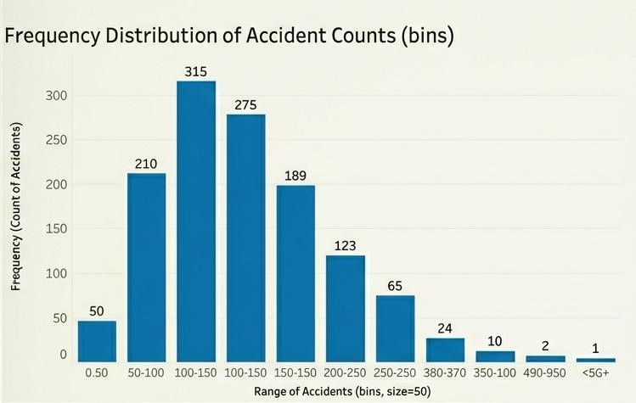

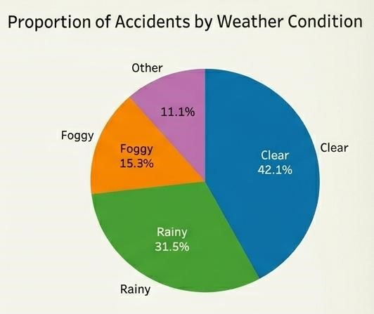

Result:
The Histogram successfully modeled the data distribution, and the Pie Chart identified the dominant environmental factors contributing to accidents.
EX.NO 3: Drawing Histogram and Pie Chart- Road Accident Analysis
Date:
Aim:
To conduct a statistical audit of fatality ranges across road types and visualize the operational timeline of emergency road clearance.

Applications:
- Severity Analysis: Identifying statistical outliers (extreme cases) in fatality data.
- Response Time Tracking: Visualizing the efficiency of the "Golden Hour" in emergency medical services.
- Risk Spread Comparison: Comparing how widely fatality rates vary between urban and rural settings.
- Administrative Audit: Documenting road closure durations for official government records.
- Efficiency Benchmarking: Setting targets for reducing road clearance times.

Procedure:
- Box Plot Setup:
  - Drag Road_Type to Columns and Fatality_Rate to Rows. oGo to the Analysis menu and uncheck Aggregate Measures. This is a critical step to ensure every individual incident is plotted.
  - Select Box Plot from the Show Me panel. oRight-click the axis to Edit Reference Line to customize the "Whiskers" to 1.5 times the Interquartile Range.
- Gantt Chart Setup:
  - Drag Accident_Date to Columns (Right-click and set to Exact Date). o Drag Region to Rows.
  - Create a Calculated Field named Duration_of_Clearance (e.g., [End Time] - [Start Time]).
  - Drag this new field to the Size marks card.
- Visual Styling:
  - Drag Road_Type to Color on the Gantt chart to see which road categories take longer to clear.

Output :

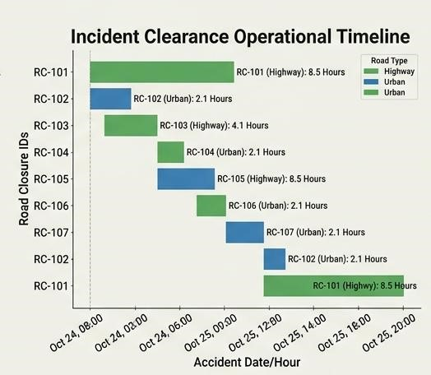

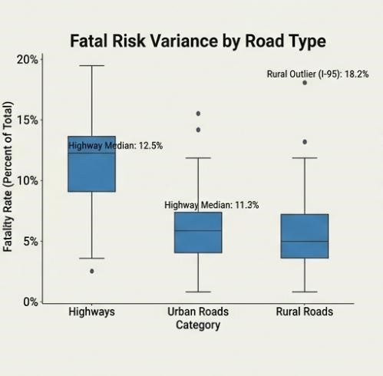

Result:
The Box Plot successfully identified high-variance regions for fatalities, and the Gantt chart mapped the operational timeline for accident management.

EX.NO 4: Box Plot and Gantt Chart- Road Accident Analysis
Date:
Aim:
To analyze historical accident data using mathematical trend lines to forecast future safety trajectories.
Applications:
- Predictive Policing: Anticipating surges in traffic violations before they occur.
- Goal Monitoring: Tracking the progress of "Vision Zero" safety initiatives over time.
- Seasonal Identification: Identifying specific months (e.g., December) where accidents consistently peak.
- Infrastructure Evaluation:Observing if accident rates drop after a new highway project is completed.
- Budget Estimation: Projecting future healthcare costs based on accident volume trends.

Procedure:
- Time Series Creation:
  - Drag Accident_Date to the Columns shelf. Right-click it and select the Continuous Month (the second "May 2015" option in the list).
  - Drag Accidents_Count to the Rows shelf.
- Adding the Trend Line:
  - Switch from the Data pane to the Analytics pane on the left-hand sidebar.
  - Drag the Trend Lineobject onto the chart. Choose the Linear model for a straight-line forecast.
- Statistical Validation:
oHover over the trend line to view the R-Squared value and P-value. A lower Pvalue (< 0.05) indicates a statistically significant trend.
- Formatting:
oRight-click the trend line and select Describe Trend Model to get the exact mathematical equation ($y = mx + c$) for the report.

Output :

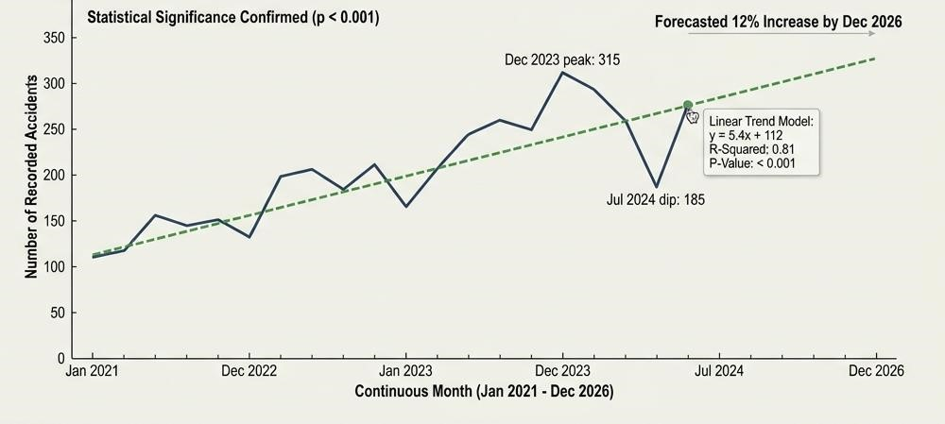

Result:
A statistically significant trend line was established, providing a reliable forecast for future road accident occurrences.

EX.NO 5: Drawing Trend Line- Road Accident Analysis
Date:
Aim:
To investigate and visualize the correlation between vehicle speed and the resulting accident fatality rate.
Applications:
- Speed Limit Justification: Providing visual proof for the necessity of "Slow Zones."
- Vehicle Risk Profile: Comparing if certain vehicle types cause more fatalities at lower speeds.
- Insurance Risk Assessment: Using correlation data to set premiums for high-speed corridors.
- Safety Engineering: Evaluating if road design (curves) influences the speed-to-fatality ratio.
- Legislative Support: Using scatter plots as evidence for passing new traffic safety bills.

Procedure:
- Coordinate Setup:
  - Drag Average_Speed to the Columns shelf (X-axis).
  - Drag Fatality_Rate to the Rows shelf (Y-axis).
- Data Point Disaggregation:
  - Navigate to the Analysis menu at the top. Uncheck Aggregate Measures so each individual accident becomes a distinct dot on the plot.
- Visual Categorization:
  - Drag Road_Type or Vehicle_Type to the Colormarks card to distinguish between different categories in the scatter field.
- Correlation Line:
  - From the Analytics pane, drag a Trend Line onto the plot. A positive upward slope confirms that higher speeds correlate with higher fatality rates.

Output :
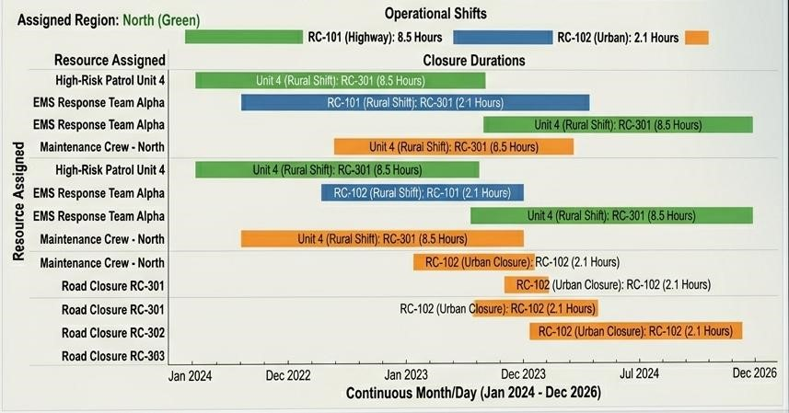

Result:
The scatter plot effectively demonstrated the positive correlation between vehicle speed and severity, providing a basis for speed management policies.

EX.NO 6: Creating or Modifying a Schedule- Road Accident Analysis
Date:

Aim: To clean and refine a comprehensive road dataset by isolating high-severity incidents and prioritizing them through advanced sorting.
Applications:
- Priority Intersection List: Generating a list of the 10 most dangerous crossings for immediate repair.
- Night-Safety Analysis: Filtering data to show only "Low Light" or "Night" conditions.
- Regional Safety Ranking: Sorting districts to determine which administrative area is performing best.
- Outlier Removal: Filtering out incomplete records or extreme anomalies for cleaner reporting.
- Executive Summary: Presenting only the most critical "Top 5" risk factors to stakeholders.

Procedure:
- Chart Initialization:
  - Drag Region to Rows and Accidents_Count to Columns to create a basic bar chart.
- Applying Filters:
  - Drag the Fatality_Rate measure to the Filters shelf. oSelect All Values, then set a range (e.g., Minimum 0.10) to show only highseverity regions. oRight-click the Weather dimension in the Data pane and select Show Filter to add an interactive dropdown to the view.
- Sorting Logic:
  - Hover over the Region axis. Click the Sort icon that appears to arrange the bars in descending order.
  - Alternatively, right-click the Region pill in the Rows shelf, select Sort, and choose Sort by Field $\rightarrow$ Accidents_Count.

Output :

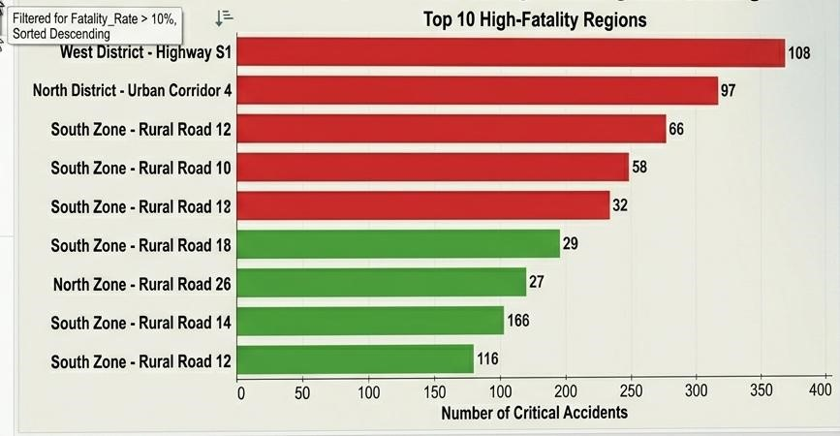

Result:
The dataset was successfully optimized to highlight high-priority "red zones," allowing for focused safety analysis.

EX.NO 7: Working with Data, Filter, Sorting- Road Accident Analysis
Date:
Aim: To visualize and modify emergency response schedules based on peak accident intervals.

Applications:
- Patrol Shift Alignment: Ensuring the highest number of officers are on duty during high-accident hours.
- Maintenance Scheduling: Planning road work for hours with the lowest historical accident rates.
- Emergency Drill Timing: Coordinating safety drills during low-traffic windows.
- Equipment Rotation: Scheduling the movement of mobile speed cameras between sites.
- Holiday Staffing: Adjusting personnel schedules for high-volume festival periods.

Procedure:
1.Gantt Implementation:
- Load a dataset containing Patrol_Shift_Start and Shift_Duration. o Drag Patrol_Shift_Start to Columns (Set to Hour). o Drag Officer_ID or Patrol_Unit to Rows.
- Drag Shift_Duration to the Sizemarks card to determine the length of the bars.
2.Contextual Filtering:
- Add a second axis or a background highlight showing Accident_Peak_Hours to see if the schedules align with the risk.
3.Interactive Modification:
o Add a Filter for Region so the user can see schedules for specific administrative zones.

Output :

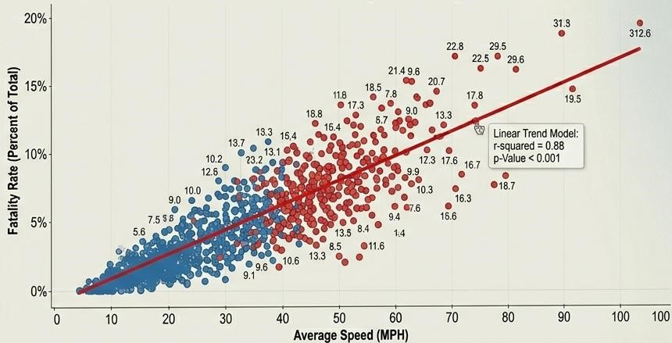

Result:
A modified resource schedule was visualized, demonstrating better alignment between officer deployment and high-risk traffic hours.

EX.NO 8: Charts and Scatter Plot- Road Accident Analysis
Date:
Aim:
To synthesize all individual road accident analyses into a cohesive, interactive dashboard for executive reporting.
Applications:
- Command Center Operations: Providing a live-style "War Room" view for traffic management.
- Interactive Stakeholder Reporting: Allowing users to filter the entire dashboard by clicking on a single map or chart.
- Public Transparency Portals: Hosting safety metrics on public-facing government websites.
- Cross-Departmental Synergy: Providing a common data platform for Police, Health, and Engineering departments.
- Strategic Decision Making: Utilizing a unified view to approve long-term safety budgets.

Procedure:
- Dashboard Assembly:
  - Click the New Dashboard tab at the bottom. Set the Sizeto "Generic Desktop" or "A4" for printing. oDrag your completed sheets (Tree Map, Trend Line, Scatter Plot, etc.) onto the canvas.
- Interactive Logic (Actions):
  - Click on the Tree Map container. Click the small funnel icon on the border (Use as Filter). oNow, clicking a specific region in the Tree Map will automatically filter the Trend Line and Scatter Plot for that region only.
- Visual Layout:
  - Add a Dashboard Title using the "Text" object. o Use Blank objects to create professional padding/spacing between charts. o Add a Legend for colors and sizes in a dedicated sidebar.

Output:
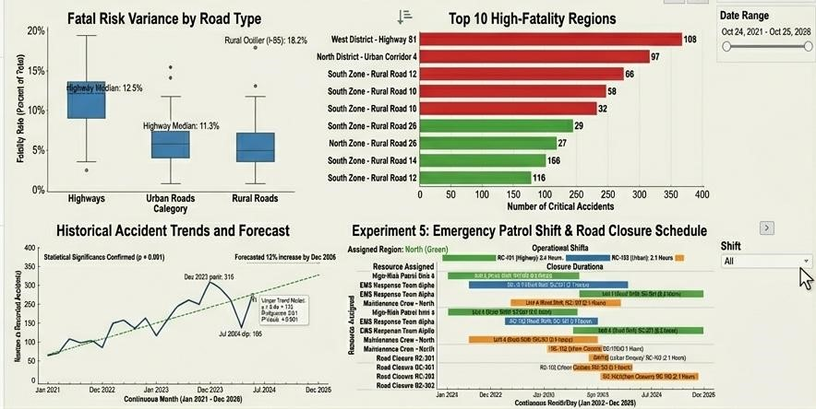

Result:
A fully functional, interactive Road Safety Dashboard was created, enabling comprehensive, data-driven analysis of accident patterns from a single interface.

